Page no. 1
Program 1. : Program to hold details of 5 students and provide the facility of viewing details of the topper as well as of specific student by providing his/her roll number.
Soln:
#include <iostream>
using namespace std;
struct Student {
int roll;
string name;
float marks;
};
int main() {
Student s[5];
int topperIndex = 0;
for (int i = 0; i < 5; i++) {
cout << "Enter Roll, Name, and Marks for student " << i + 1 << ": ";
cin >> s[i].roll >> s[i].name >> s[i].marks;
if (s[i].marks > s[topperIndex].marks) {
topperIndex = i;
}
}
cout << "\n--- TOPPER DETAILS ---\n";
cout << "Roll: " << s[topperIndex].roll
<< " | Name: " << s[topperIndex].name
<< " | Marks: " << s[topperIndex].marks << endl;
int searchRoll;
cout << "\nEnter Roll Number to search: ";
cin >> searchRoll;
bool found = false;
for (int i = 0; i < 5; i++) {
if (s[i].roll == searchRoll) {
cout << "Student Found -> Name: " << s[i].name
Page no. 2
<< ", Marks: " << s[i].marks << endl;
found = true;
break;
}
}
if (!found) cout << "Student with Roll Number " << searchRoll << " not found.\n";
return 0;
}
Output:
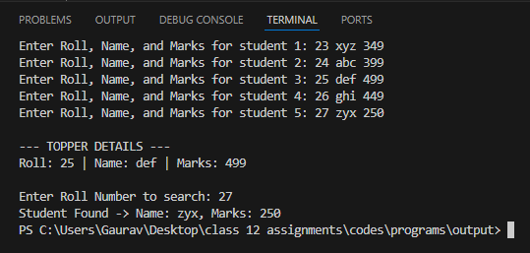

Page no. 3
Program 2. : Program to illustrate the access control in public derivation of a class with the concept of inheritance.
Soln:
#include <iostream>
using namespace std;
class Base {
private:
int priv = 10;
protected:
int prot = 20;
public:
int pub = 30;
int getPrivate() { return priv; }
};
class Derived : public Base {
public:
void display() {
cout << "Accessing private via Base method: " << getPrivate() << endl;
cout << "Accessing protected member: " << prot << endl;
cout << "Accessing public member: " << pub << endl;
}
};
int main() {
Derived obj;
obj.display();
cout << "Direct public access from main: " << obj.pub << endl;
return 0;
}

Page no. 4

Output:
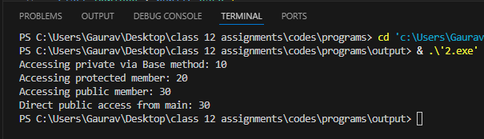

Page no. 5
Program 3. : Program to illustrate the use of object arrays by storing details of 5 items in an array of objects.
Soln:
#include <iostream>
using namespace std;
class Item {
int id;
string name;
float price;
public:
void getItem() {
cout << "Enter Item ID, Name, and Price: ";
cin >> id >> name >> price;
}
void putItem() const {
cout << "ID: " << id << " | Name: " << name << " | Price: Rs " << price << endl;
}
};
int main() {
Item items[5];
for (int i = 0; i < 5; i++) {
cout << "Item " << i + 1 << ":\n";
items[i].getItem();
}
cout << "\n--- ITEM DETAILS ---\n";
for (int i = 0; i < 5; i++) {
items[i].putItem();
}
return 0;
}

Page no. 6

Output:
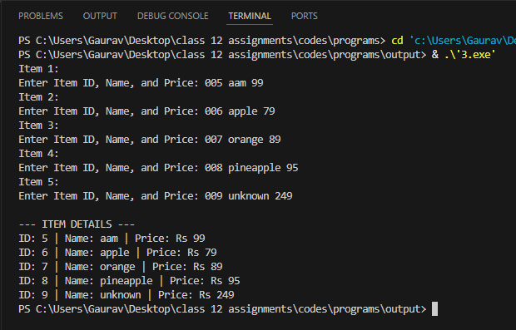

Page no. 7
Program 4. : Program to illustrate the working of a function returning an object.
Soln:
#include <iostream>
using namespace std;
class Point {
public:
int x, y;
Point(int xVal = 0, int yVal = 0) : x(xVal), y(yVal) {}
void display() const {
cout << "(" << x << ", " << y << ")" << endl;
}
};
Point addPoints(Point p1, Point p2) {
Point temp(p1.x + p2.x, p1.y + p2.y);
return temp;
}
int main() {
Point p1(4, 5), p2(6, 7);
Point p3 = addPoints(p1, p2);
cout << "p1 = "; p1.display();
cout << "p2 = "; p2.display();
cout << "p3 (Sum) = "; p3.display();
return 0;
}

Page no. 8

Output:
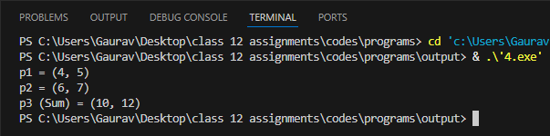

Page no. 9
Program 5. : Program to illustrate the Call By Reference mechanism on objects.
Soln:
#include <iostream>
using namespace std;
class Number {
public:
int val;
Number(int v) : val(v) {}
};
void swapObjects(Number &n1, Number &n2) {
int temp = n1.val;
n1.val = n2.val;
n2.val = temp;
}
int main() {
Number a(10), b(20);
cout << "Before Swap: a = " << a.val << ", b = " << b.val << endl;
swapObjects(a, b);
cout << "After Swap: a = " << a.val << ", b = " << b.val << endl;
return 0;
}

Output :
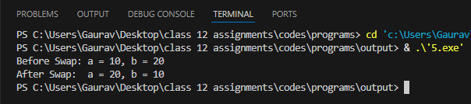

Page no. 10
Program 6. : Program to Sort elements of an array.
Soln:
#include <iostream>
using namespace std;
int main() {
int n, arr[100];
cout << "Enter number of elements: ";
cin >> n;
cout << "Enter " << n << " integers: ";
for (int i = 0; i < n; i++) cin >> arr[i];
for (int i = 0; i < n - 1; i++) {
for (int j = 0; j < n - i - 1; j++) {
if (arr[j] > arr[j + 1]) {
int temp = arr[j];
arr[j] = arr[j + 1];
arr[j + 1] = temp;
}
}
}
cout << "Sorted Array: ";
for (int i = 0; i < n; i++) cout << arr[i] << " ";
cout << endl;
return 0;
}
Output:
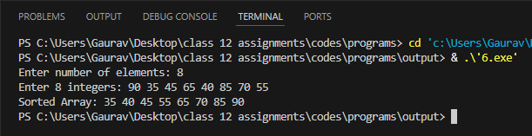

Page no. 11
Program 7. : Program demonstrating Linear searching.
Soln:
#include <iostream>
using namespace std;
int main() {
int n, key, arr[100];
cout << "Enter array size: ";
cin >> n;
cout << "Enter elements: ";
for (int i = 0; i < n; i++) cin >> arr[i];
cout << "Enter element to search: ";
cin >> key;
int pos = -1;
for (int i = 0; i < n; i++) {
if (arr[i] == key) {
pos = i;
break;
}
}if (pos != -1)
cout << "Element found at index " << pos << " (Position " << pos + 1 << ")\n";
else
cout << "Element not found.\n";
return 0;
}
Output: 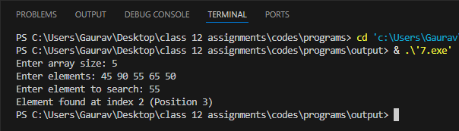
Page no. 12
Program 8. : Program demonstrating Binary search.
Soln:
#include <iostream>
using namespace std;
int main() {
int n, key, arr[100];
cout << "Enter size of sorted array: ";
cin >> n;
cout << "Enter sorted elements: ";
for (int i = 0; i < n; i++) cin >> arr[i];
cout << "Enter element to search: ";
cin >> key;
int low = 0, high = n - 1, mid, index = -1;
while (low <= high) {
mid = low + (high - low) / 2;
if (arr[mid] == key) {
index = mid;
break;
} else if (arr[mid] < key) {
low = mid + 1;
} else {
high = mid - 1;
}
}if (index != -1)
cout << "Element found at index: " << index << endl;
else
cout << "Element not found.\n";
return 0;
}

Page no. 13

Output:
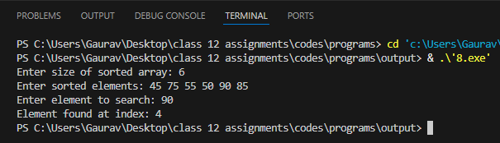

Pgae no. 14
Program 9. : Program for Inserting elements into the array.
Soln:
#include <iostream>
using namespace std;
int main() {
int n, val, pos, arr[100];
cout << "Enter number of elements: ";
cin >> n;
cout << "Enter elements: ";
for (int i = 0; i < n; i++) cin >> arr[i];
cout << "Enter value and position (1-based) to insert: ";
cin >> val >> pos;
for (int i = n; i >= pos; i--) {
arr[i] = arr[i - 1];
}
arr[pos - 1] = val;
n++;
cout << "Updated Array: ";
for (int i = 0; i < n; i++) cout << arr[i] << " ";
cout << endl;
return 0;
}
Output:
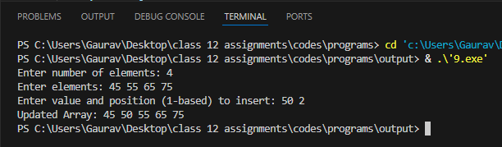

Page no. 15
Program 10. : Program for Deleting elements on the array.
Soln:
#include <iostream>
using namespace std;
int main() {
int n, pos, arr[100];
cout << "Enter number of elements: ";
cin >> n;
cout << "Enter elements: ";
for (int i = 0; i < n; i++) cin >> arr[i];
cout << "Enter position (1-based) to delete: ";
cin >> pos;
if (pos < 1 || pos > n) {
cout << "Invalid position!\n";
} else {
for (int i = pos - 1; i < n - 1; i++) {
arr[i] = arr[i + 1];
}
n--;
cout << "Updated Array: ";
for (int i = 0; i < n; i++) cout << arr[i] << " ";
cout << endl;
}
return 0;
}

Page no. 16
Output:
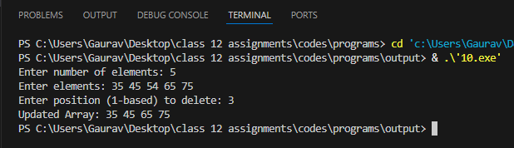

Page no. 17
Program 11. : Write a C++ program that inputs a line of text and a substring to search for. Then it should display the position of the first and last occurrence of the word.
Soln:
#include <iostream>
#include <string>
using namespace std;
int main() {
string text, sub;
cout << "Enter full line of text: ";
getline(cin, text);
cout << "Enter substring to search: ";
cin >> sub;
size_t first = text.find(sub);
size_t last = text.rfind(sub);
if (first == string::npos) {
cout << "Substring not found in the given text.\n";
} else {
cout << "First occurrence index: " << first << endl;
cout << "Last occurrence index: " << last << endl;
}
return 0;
}
Output:
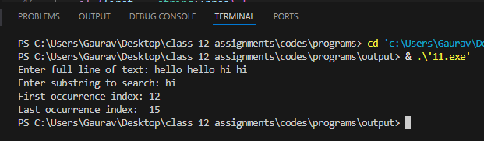

Page no. 18
Program 12. : Program to illustrate summation of Matrices.
Soln:
#include <iostream>
using namespace std;
int main() {
int r, c, a[10][10], b[10][10], sum[10][10];
cout << "Enter rows and columns: ";
cin >> r >> c;
cout << "Enter Matrix A elements:\n";
for (int i = 0; i < r; i++)
for (int j = 0; j < c; j++)
cin >> a[i][j];
cout << "Enter Matrix B elements:\n";
for (int i = 0; i < r; i++)
for (int j = 0; j < c; j++)
cin >> b[i][j];
for (int i = 0; i < r; i++)
for (int j = 0; j < c; j++)
sum[i][j] = a[i][j] + b[i][j];
cout << "\nResultant Sum Matrix:\n";
for (int i = 0; i < r; i++) {
for (int j = 0; j < c; j++) {
cout << sum[i][j] << " ";
}
cout << endl;
}
return 0;
}

Page no. 19

Output:
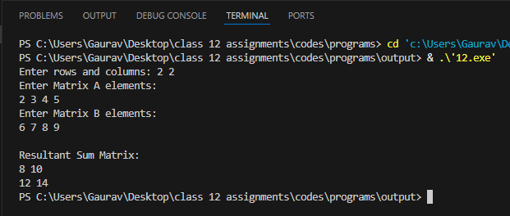

Page no. 20
Program 13. : Write a C++ program to find the Longest consecutive sequence of integers with no primes. The program should accept a number N and print out the Largest block of integers between 2 and N with no primes.
Soln:
#include <iostream>
using namespace std;
bool isPrime(int n) {
if (n < 2) return false;
for (int i = 2; i * i <= n; i++) {
if (n % i == 0) return false;
}
return true;
}
int main() {
int n;
cout << "Enter N (>= 2): ";
cin >> n;
int maxLen = 0, maxStart = 0;
int curLen = 0, curStart = 0;
for (int i = 2; i <= n; i++) {
if (!isPrime(i)) {
if (curLen == 0) curStart = i;
curLen++;
if (curLen > maxLen) {
maxLen = curLen;
maxStart = curStart;
}} else {
curLen = 0;
}
}
if (maxLen > 0) {
Page no. 21

cout << "Longest consecutive sequence of non-primes (Length " << maxLen << "): ";
for (int i = maxStart; i < maxStart + maxLen; i++) {
cout << i << " ";
}
cout << endl;
} else {
cout << "No composite sequence found between 2 and " << n << ".\n";
}
return 0;
}

Output:
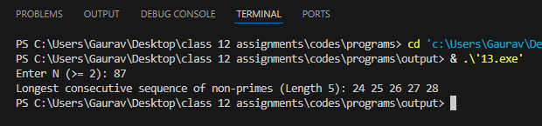

Page no. 22
Program 14. : Write a function in C++ to count the words "this" and "these" present in a text file "ARTICLE.TXT".
Soln:
#include <iostream>
#include <fstream>
#include <string>
#include <algorithm>
using namespace std;
void countWords() {
ifstream file("ARTICLE.TXT");
if (!file) {
cout << "Error: Cannot open ARTICLE.TXT\n";
return;
}
string word;
int countThis = 0, countThese = 0;
while (file >> word) {
string cleanWord = "";
for (char ch : word) {
if (isalpha(ch)) cleanWord += tolower(ch);
}
if (cleanWord == "this") countThis++;
if (cleanWord == "these") countThese++;
}
file.close();
cout << "Count of 'this': " << countThis << endl;
cout << "Count of 'these': " << countThese << endl;
}
int main() {
countWords();

Page no. 23
return 0;
}
Output:
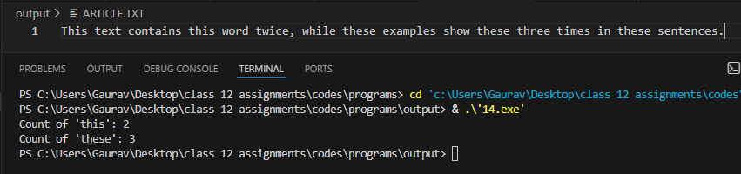

Page no. 24
Program 15. : Write a C++ program that displays the size of a file in bytes.
Soln:
#include <iostream>
#include <fstream>
#include <string>
using namespace std;
int main() {
string filename;
cout << "Enter file name: ";
cin >> filename;
ifstream file(filename, ios::binary | ios::ate);
if (!file) {
cout << "Error opening file or file does not exist!\n";
return 1;
}
streampos size = file.tellg();
file.close();
cout << "File Size: " << size << " bytes\n";
return 0;
}
Output:
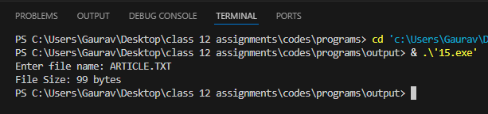

Page no. 25
Program 16. : Program for Insertion at the beginning of a List.
Soln:
#include <iostream>
using namespace std;
struct Node {
int data;
Node* next;
};
void insertAtBeginning(Node*& head, int val) {
Node* newNode = new Node{val, head};
head = newNode;
}
void display(Node* head) {
Node* temp = head;
while (temp != nullptr) {
cout << temp->data << " -> ";
temp = temp->next;
}
cout << "NULL\n";
}
int main() {
Node* head = nullptr;
insertAtBeginning(head, 30);
insertAtBeginning(head, 20);
insertAtBeginning(head, 10);
cout << "Linked List after insertions at beginning: ";
display(head);
return 0;
}

Page no. 26

Output:
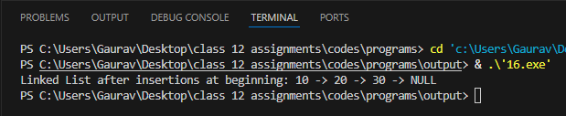

Page no. 27
Program 17. : Program for Insertion at the end of a List.
Soln:
#include <iostream>
using namespace std;
struct Node {
int data;
Node* next;
};
void insertAtEnd(Node*& head, int val) {
Node* newNode = new Node{val, nullptr};
if (head == nullptr) {
head = newNode;
return;
}
Node* temp = head;
while (temp->next != nullptr) {
temp = temp->next;
}
temp->next = newNode;
}
void display(Node* head) {
Node* temp = head;
while (temp != nullptr) {
cout << temp->data << " -> ";
temp = temp->next;
}
cout << "NULL\n";
}
int main() {
Node* head = nullptr;

Page no. 28
insertAtEnd(head, 10);
insertAtEnd(head, 20);
insertAtEnd(head, 30);
cout << "Linked List after insertions at end: ";
display(head);
return 0;
}
Output:
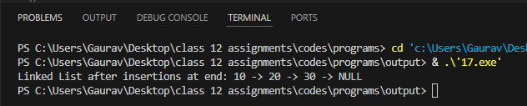

Page no. 29
Program 18. : Write a C++ program to declare a pointer to an integer, assign a value to it, and print the value using the pointer.
Soln:
#include <iostream>
using namespace std;
int main() {
int num = 42;
int* ptr = &num;
cout << "Value of num directly: " << num << endl;
cout << "Address stored in ptr: " << ptr << endl;
cout << "Value accessed via pointer (*ptr): " << *ptr << endl;
*ptr = 99;
cout << "Value after modifying via pointer: " << num << endl;
return 0;
}
Output:
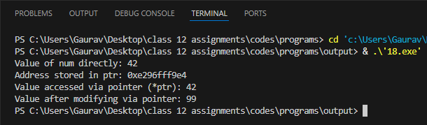

Page no. 30
Program 19. : Write a C++ program that demonstrates polymorphism. Create a base class Shape with a function area(). Derive a class Circle and override the area() function to calculate the area of a circle.
Soln:
#include <iostream>
using namespace std;
class Shape {
public:
virtual void area() const {
cout << "Base Shape area undefined.\n";
}
virtual ~Shape() {}
};
class Circle : public Shape {
double radius;
public:
Circle(double r) : radius(r) {}
void area() const override {
cout << "Area of Circle with radius " << radius
<< " = " << 3.14159 * radius * radius << endl;
}
};
int main() {
Shape* shapePtr;
Circle c(7.0);
shapePtr = &c;
shapePtr->area(); // Dynamic dispatch
return 0;
}

Page no. 31

Output:
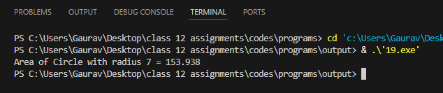

Page no. 32
Program 20. : Write a C++ program with a class Book that uses a constructor to initialize title and author, and a destructor that prints a message when an object is destroyed.
Soln:
#include <iostream>
using namespace std;
class Book {
string title;
string author;
public:
Book(string t, string a) : title(t), author(a) {
cout << "Book Created: \"" << title << "\" by " << author << endl;
}
~Book() {
cout << "Book Destroyed: \"" << title << "\" by " << author << endl;
}
void display() const {
cout << "Title: " << title << " | Author: " << author << endl;
}
};
int main() {
{
Book b1("Harry Potter and the Sorcerer's Stone", "J.K. Rowling");
Book b2("Harry Potter and the Chamber of Secrets", "J.K. Rowling");
Book b3("Harry Potter and the Prisoner of Azkaban", "J.K. Rowling");
cout << "\n--- Displaying Books ---\n";
b1.display();
b2.display();
b3.display();
cout << "------------------------\n\n";
}

Page no. 33
cout << "End of main scope.\n";
return 0;
}

Output:
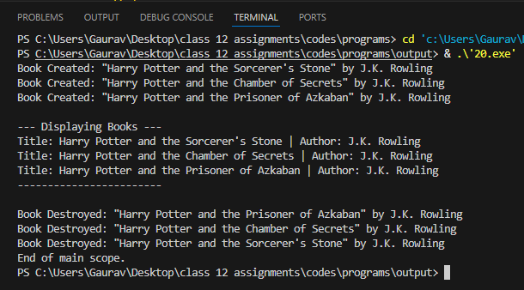

Page no. 34
Program 21. : Write a C++ program to create a binary file for records (ID, Name, Marks), a text file for logs, update records in the binary file, append data to the text file, and query records by ID with proper error handling using fstream.
Soln:
#include <iostream>
#include <fstream>
#include <cstring>
using namespace std;
struct Record {
int id;
char name[50];
float marks;
};
void logMessage(const string& msg) {
ofstream logFile("log.txt", ios::app);
if (logFile) {
logFile << msg << endl;
}
}
void addRecord(int id, const char* name, float marks) {
ofstream out("records.dat", ios::binary | ios::app);
if (!out) {
cout << "Error opening binary file!\n";
return;
}
Record r;
r.id = id;
strncpy(r.name, name, sizeof(r.name) - 1);
r.name[sizeof(r.name) - 1] = '\0';
r.marks = marks;
out.write(reinterpret_cast<char*>(&r), sizeof(Record));
Page no. 35
out.close();
logMessage("Added record with ID: " + to_string(id));
}
void queryRecord(int id) {
ifstream in("records.dat", ios::binary);
if (!in) {
cout << "Binary file not found!\n";
return;
}
Record r;
bool found = false;
while (in.read(reinterpret_cast<char*>(&r), sizeof(Record))) {
if (r.id == id) {
cout << "Found -> ID: " << r.id << ", Name: " << r.name << ", Marks: " << r.marks << endl;
found = true;
break;
}
}
if (!found) cout << "Record with ID " << id << " not found.\n";
in.close();
}
void updateMarks(int id, float newMarks) {
fstream file("records.dat", ios::binary | ios::in | ios::out);
if (!file) {
cout << "File error!\n";
return;
}
Record r;
bool found = false;
while (file.read(reinterpret_cast<char*>(&r), sizeof(Record))) {

Page no. 36
if (r.id == id) {
r.marks = newMarks;
file.seekp(-static_cast<streamoff>(sizeof(Record)), ios::cur);
file.write(reinterpret_cast<char*>(&r), sizeof(Record));
found = true;
logMessage("Updated ID " + to_string(id) + " with new marks: " + to_string(newMarks));
cout << "Record updated.\n";
break;
}
}
if (!found) cout << "ID not found for update.\n";
file.close();
}
int main() {
addRecord(101, "Alice", 88.5);
addRecord(102, "Bob", 92.0);
cout << "Querying ID 101:\n";
queryRecord(101);
cout << "\nUpdating Marks for ID 101:\n";
updateMarks(101, 95.0);
cout << "\nQuerying ID 101 after update:\n";
queryRecord(101);
return 0;
}

Page no. 37

Output:
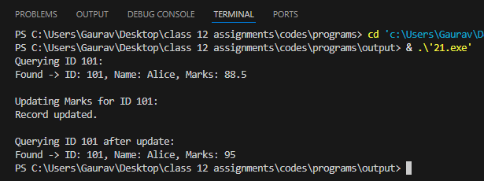

Page no. 38
Program 22. : Write a menu-driven C++ program to implement stack operations (push, pop, peek, and display) using a linear stack with arrays, a circular stack with arrays, and a stack with a linked list.
Soln:
#include <iostream>
using namespace std;
// 1. Linear Stack using Fixed Array
class LinearStack {
int top, cap;
int arr[50];
public:
LinearStack(int c = 10) : top(-1), cap(c) {}
void push(int val) {
if (top == cap - 1) {
cout << "Stack Overflow!\n";
return;
}
arr[++top] = val;
cout << "Pushed: " << val << endl;
}
void pop() {
if (top == -1) {
cout << "Stack Underflow!\n";
return;
}
cout << "Popped: " << arr[top--] << endl;
}
void peek() {
if (top == -1) {
cout << "Stack is Empty.\n";
} else {
Page no. 39
cout << "Top element: " << arr[top] << endl;
}
}
void display() {
if (top == -1) {
cout << "Stack is Empty.\n";
return;
}
cout << "Linear Stack (Top to Bottom): ";
for (int i = top; i >= 0; i--) {
cout << arr[i] << " ";
}
cout << endl;
}
};
// 2. Circular Stack using Array (With Wrap-around Logic)
class CircularStack {
int top, cap, size;
int arr[50];
public:
CircularStack(int c = 10) : top(-1), cap(c), size(0) {}
void push(int val) {
if (size == cap) {
cout << "Circular Stack Overflow!\n";
return;
}
top = (top + 1) % cap;
arr[top] = val;
size++;
cout << "Pushed: " << val << endl;

Page no. 40
}
void pop() {
if (size == 0) {
cout << "Circular Stack Underflow!\n";
return;
}
cout << "Popped: " << arr[top] << endl;
top = (top - 1 + cap) % cap;
size--;
}
void peek() {
if (size == 0) {
cout << "Circular Stack is Empty.\n";
} else {
cout << "Top element: " << arr[top] << endl;
}
}
void display() {
if (size == 0) {
cout << "Circular Stack is Empty.\n";
return;
}
cout << "Circular Stack (Top to Bottom): ";
int curr = top;
for (int i = 0; i < size; i++) {
cout << arr[curr] << " ";
curr = (curr - 1 + cap) % cap;
}
cout << endl;
}

Page no. 41
};
// 3. Stack using Linked List
struct SNode {
int data;
SNode* next;
};
class LinkedStack {
SNode* top;
public:
LinkedStack() : top(nullptr) {}
void push(int val) {
SNode* newNode = new SNode();
newNode->data = val;
newNode->next = top;
top = newNode;
cout << "Pushed: " << val << endl;
}
void pop() {
if (!top) {
cout << "Stack Underflow!\n";
return;
}
SNode* temp = top;
cout << "Popped: " << temp->data << endl;
top = top->next;
delete temp;
}
void peek() {
if (!top) {
cout << "Stack is Empty.\n";

Page no. 42
} else {
cout << "Top element: " << top->data << endl;
}
}
void display() {
if (!top) {
cout << "Stack is Empty.\n";
return;
}
cout << "Linked Stack (Top to Bottom): ";
for (SNode* p = top; p != nullptr; p = p->next) {
cout << p->data << " -> ";
}
cout << "NULL\n";
}
// Destructor to clean up memory
~LinkedStack() {
while (top != nullptr) {
SNode* temp = top;
top = top->next;
delete temp;
}
}
};
int main() {
LinearStack ls;
CircularStack cs;
LinkedStack lks;
int type, op, val;
while (true) {
cout << "\n===============================\n";
Page no. 43
cout << " MAIN MENU \n";
cout << "===============================\n";
cout << "1. Linear Stack (Array)\n";
cout << "2. Circular Stack (Array)\n";
cout << "3. Linked List Stack\n";
cout << "4. Exit Program\n";
cout << "Enter your choice (1-4): ";
cin >> type;
if (type == 4) break;
if (type < 1 || type > 4) {
cout << "Invalid choice! Please select 1-4.\n";
continue;
}
while (true) {
cout << "\n--- Operations Sub-Menu ---\n";
cout << "1. Push\n2. Pop\n3. Peek\n4. Display\n5. Go back to Main Menu\n";
cout << "Enter operation (1-5): ";
cin >> op;
if (op == 5) break;
if (op == 1) {
cout << "Enter value to push: ";
cin >> val;
}
// Route to correct object based on selected main type
if (type == 1) {
if (op == 1) ls.push(val);
else if (op == 2) ls.pop();
else if (op == 3) ls.peek();
else if (op == 4) ls.display();
else cout << "Invalid operation!\n";

Page no. 44
}
else if (type == 2) {
if (op == 1) cs.push(val);
else if (op == 2) cs.pop();
else if (op == 3) cs.peek();
else if (op == 4) cs.display();
else cout << "Invalid operation!\n";
}
else if (type == 3) {
if (op == 1) lks.push(val);
else if (op == 2) lks.pop();
else if (op == 3) lks.peek();
else if (op == 4) lks.display();
else cout << "Invalid operation!\n";
}
}
}
cout << "\nProgram exited successfully.\n";
return 0;
}

Page no. 45
Output:
